AWS LAB2 ITI – Intensive Training – DevOps – SV
Hadi Lotfy Al-Atally
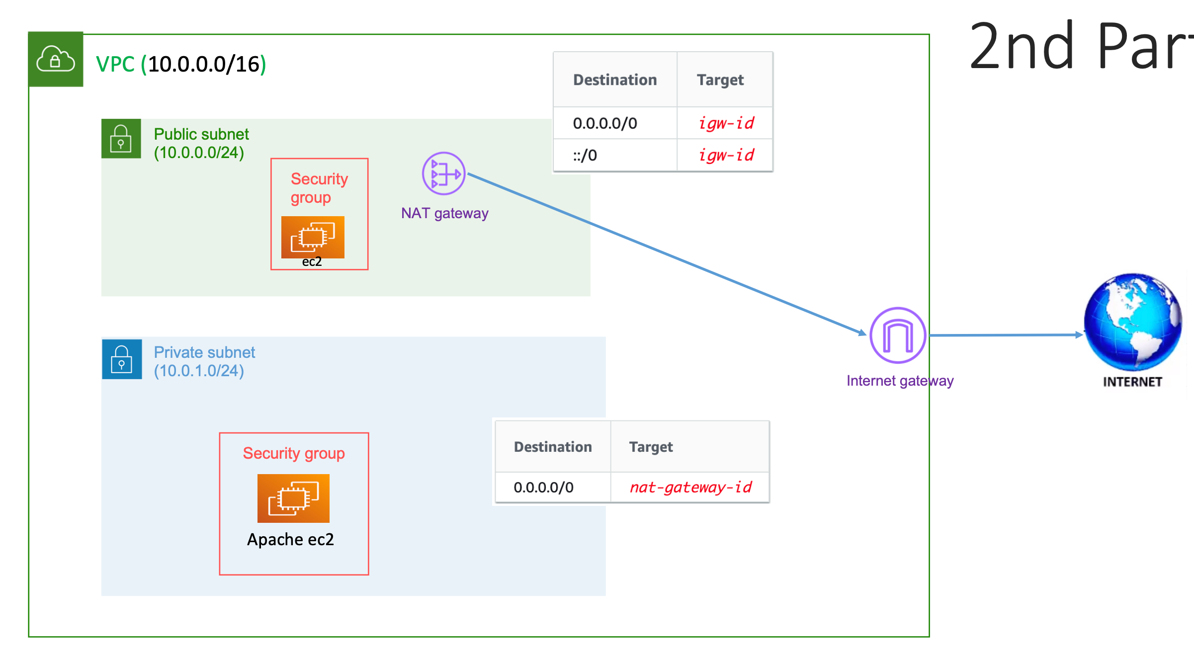

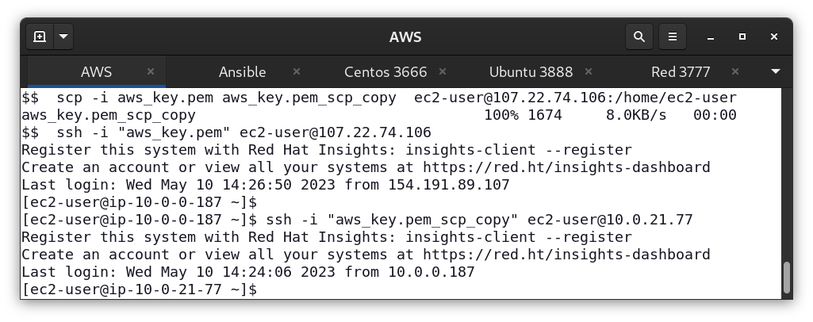
> Copying the private key using scp from my pc to the public instance.
> Connecting to the public instance then connecting to the private instance from there using the private IP address.

Required:
- Screenshot from the instance page demonstrate that the instance is private
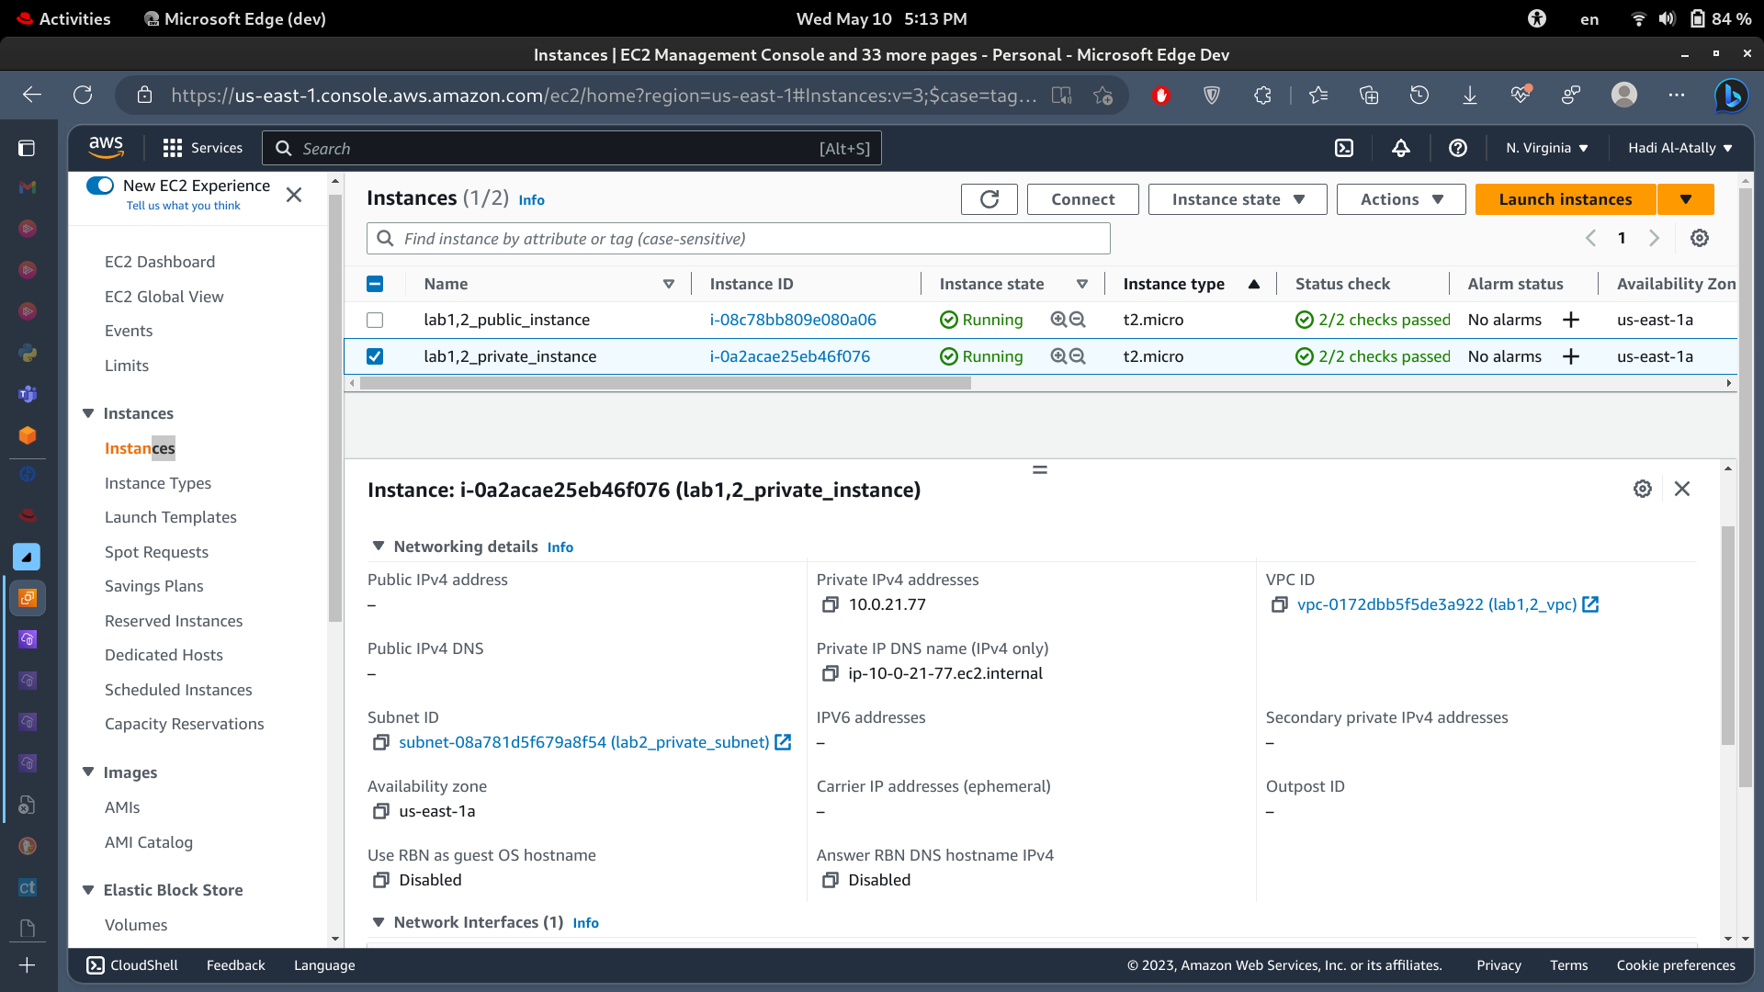
No public ipv4 assigned, and subnet is “lab2_private_subnet”

- Screenshot from the logs of the instance demonstrate the apache2 Is installed
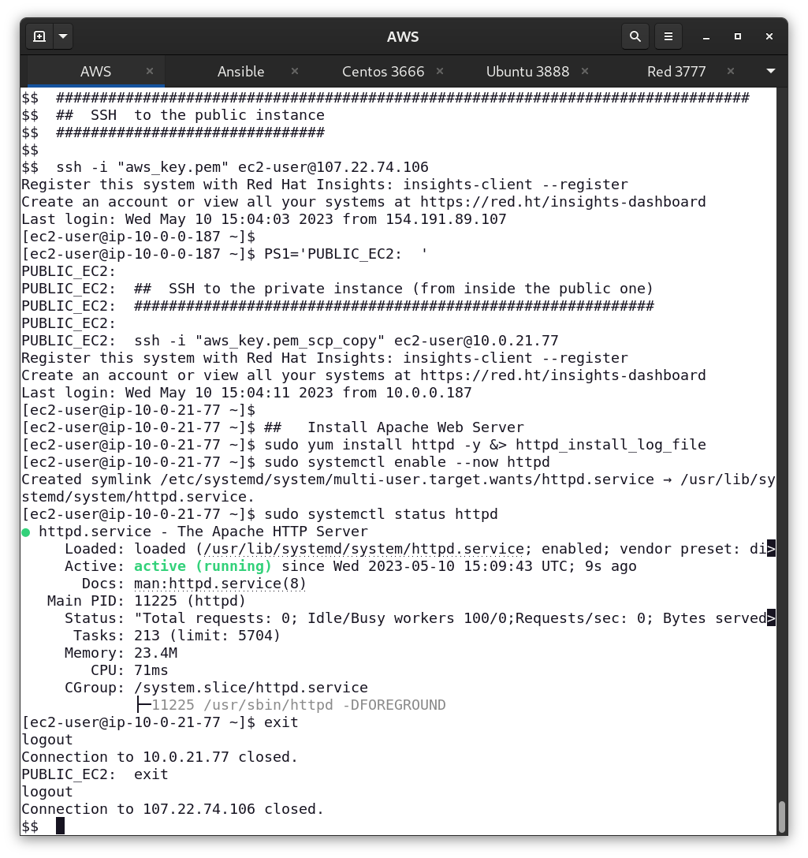
the httpd.service which is The Apache HTTP Server is Running as the green word says.

